Thank you for your help.
Your work to help promote the Youth Voice Census 2020 on your publicity and social media channels is greatly appreciated.  This annual survey is a temperature check of how young people aged 14–24 feel on issues relating to their transition from education to employment. | It is important that we hear from the widest cohort of young people so we can provide a detailed picture of the youth population.  We hope the following information is useful when spreading the word among your peers, networks and colleagues.

Social media pack contents
Press release, CEO quote and editor notes
Suggested imagery to include with online/social promotion
Suggested tweets and social messages

Census link

https://www.surveymonkey.co.uk/r/youthcensus2020

Press release
“Our annual Youth Voice Census allows young people to share their voice on the experiences and services available to them throughout education and their next steps. Last year over 3,000 young people told us their story, enabling us to build a picture of how young people are navigating the transition from education to employment. We have been able to share what is working and what improvements need to be made with partners across the sector and with UK Government policy makers.
Youth voice is vital to ensuring services really work for our young people, and this is their chance to be heard”.
Laura-Jane Rawlings, CEO of Youth Employment UK
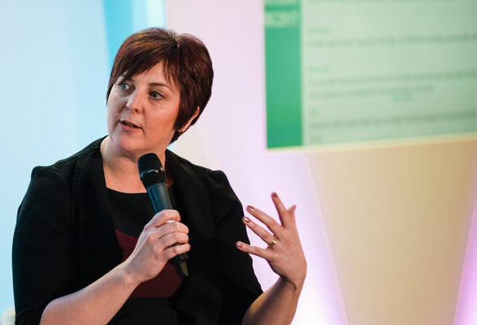

More on the Youth Voice Census
The Youth Voice Census is an annual survey, presented as a report with the results made available to the public shortly after the survey closes. The census explores youth employment issues including (but not limited to) careers advice, apprenticeships, social action and unemployment provision. Developed in collaboration with The Careers and Enterprise Company, Pearson, The Skills Builder Partnership and BP, the Youth Voice Census has also received support from subject experts including Education and Employers, NCS, WorldSkills UK, DfE and NYA.
The census will remain open until 6th April 2020.

More about Youth Employment UK
Youth Employment UK is an independent, not for profit social enterprise founded in 2012 to tackle youth unemployment.
As experts on youth employment and unemployment, we are ideally placed to understand the complex landscape facing young people, employers and policy makers.
We are actively tackling youth unemployment by:
- Giving young people a voice on the youth employment issues that affect them
- Supporting young people with the skills and careers support they need to progress
- Supporting employers to develop and be recognised for their youth friendly employment practice
- Connecting young people to Youth Friendly Employers
- Providing expert insight across all youth employment policy areas
Contact info@youthemployment.org.uk for more information
Editor notes
- For all media enquiries, please contact Lauren Mistry: lauren@youthemployment.org.uk.
- Representatives from Youth Employment UK and young people from its network are available for interviews.

Social Media Assets - Image Cards
- Our Twitter account is @YEUK2012. Please follow us and retweet!
- The campaign hashtag for the Youth Voice Census is #YouthVoiceCensus
- The page link to include is https://www.youthemployment.org.uk/youth-voice-census/
- Please include our Twitter handle @YEUK2012 and #YouthVoiceCensus so we can share your posts and express our thanks for your insights and generosity.

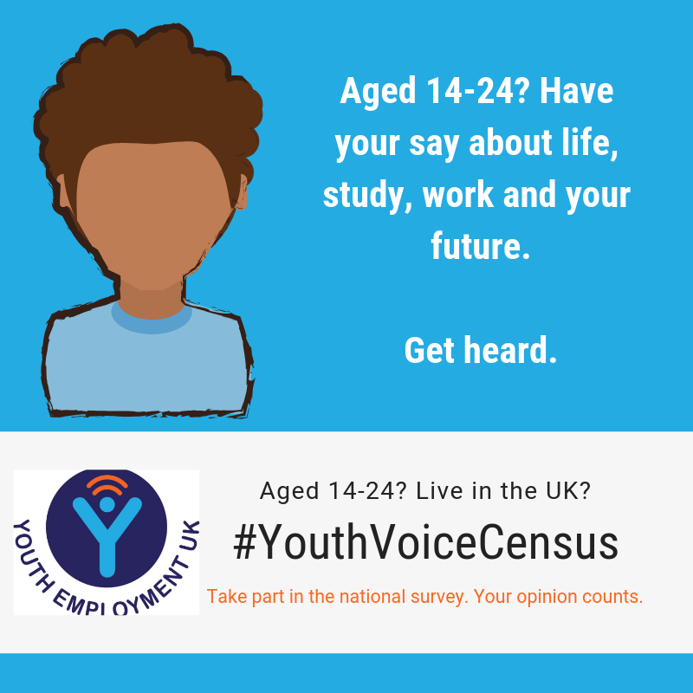  Download full-sized version of image | 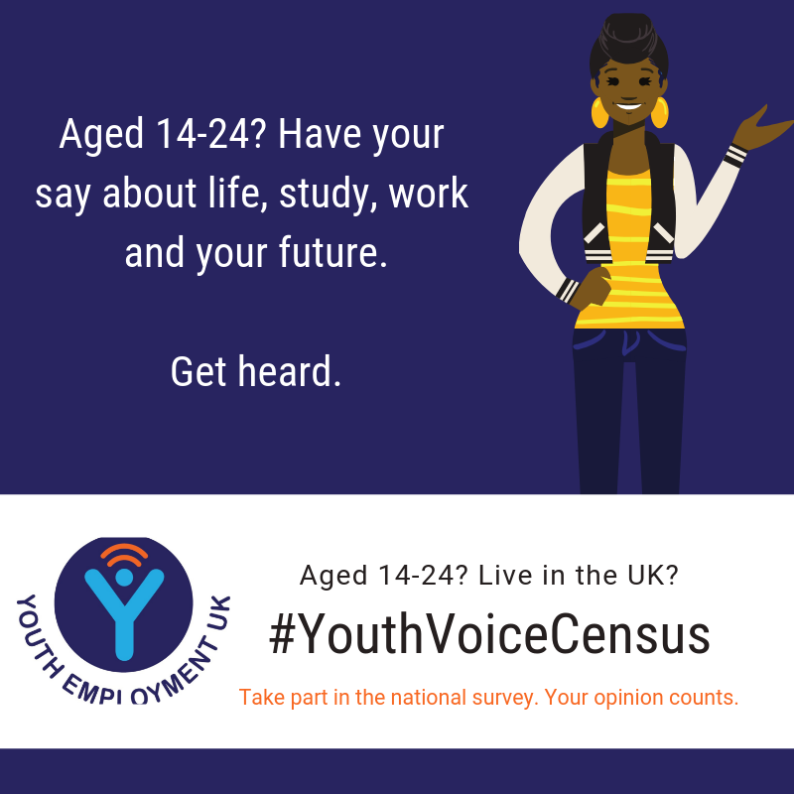  Download full-sized version of image
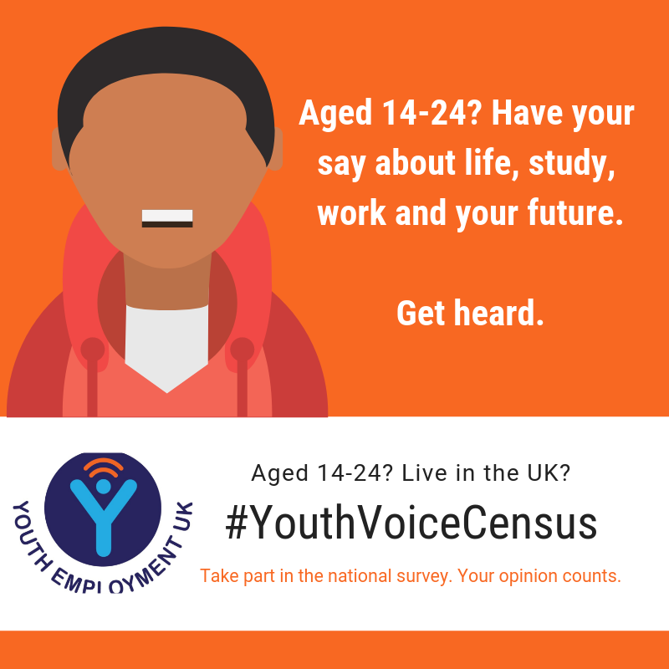  Download full-sized version of image | 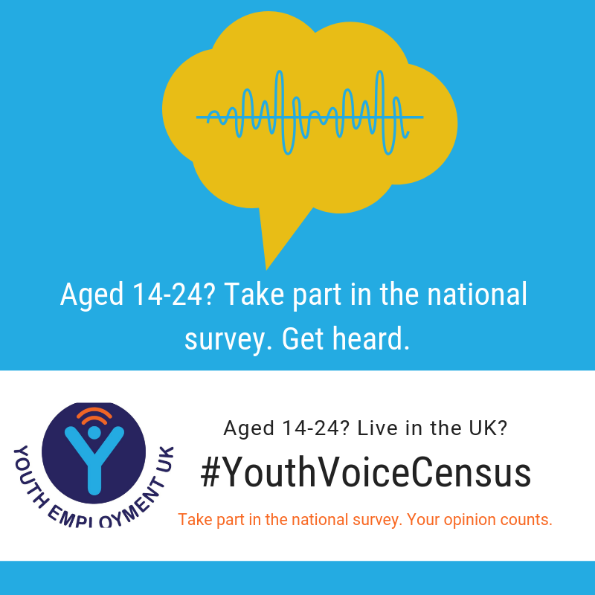  Download full-sized version of image

Social Media Assets – Tweets and Social Messages

You can use your choice of images above with these tweets – designed for a range of audiences – to share the news about the launch of the 2020 Youth Voice Census on Twitter.

Tweets for a youth audience

Share your voice on a number of views on the annual #YouthVoiceCensus 2020. 14 – 24 year olds across the UK are invited to #HaveYourSay https://www.surveymonkey.co.uk/r/youthcensus2020

Aged 14 – 24 years old? #HaveYourSay on a range of issues related to life, study and work. Share your views with @YEUK2012 and the #YouthVoiceCensus https://www.surveymonkey.co.uk/r/youthcensus2020
Are you aged 14-24? Have you got time to share your views on important youth employment issues? 20 minutes can help change things for you and other young people too! #YouthVoiceCensus https://www.surveymonkey.co.uk/r/youthcensus2020

Study. Life. Work. If you’re aged 14-24, what changes would you like to see in how you are supported from school onwards? #HaveYourSay with the #YouthVoiceCensus 2020. Share your views. Make a difference. https://www.surveymonkey.co.uk/r/youthcensus2020

Tweets for a mature audience

The @YEUK2012 UK #YouthVoiceCensus for 2020 is now underway and 14-24 year olds are invited to complete the survey on life, study and work. Census results will help to inform policy. Please share this survey to amplify the voice of young people today: https://www.surveymonkey.co.uk/r/youthcensus2020

Developed with @CareerEnt and @pearson with support from @educationgovuk, @Skills_Builder and many others, @YEUK2012’s #YouthVoiceCensus census is now underway and explores how study, work & employment issues affect young people in the UK. Share the census today: https://www.surveymonkey.co.uk/r/youthcensus2020

What do young people in the UK really think about #education, #employment and the support they get to progress in life? 14-24 year olds can have their say & help inform policy in @YEUK2012’s #YouthVoiceCensus. Share the survey and amplify youth voices: https://www.surveymonkey.co.uk/r/youthcensus2020

What do young people in the UK really think about #apprenticeships and #workexperience? 14-24 year olds can have their say & help inform policy in @YEUK2012’s #YouthVoiceCensus. Share the survey and amplify youth voices: https://www.surveymonkey.co.uk/r/youthcensus2020

