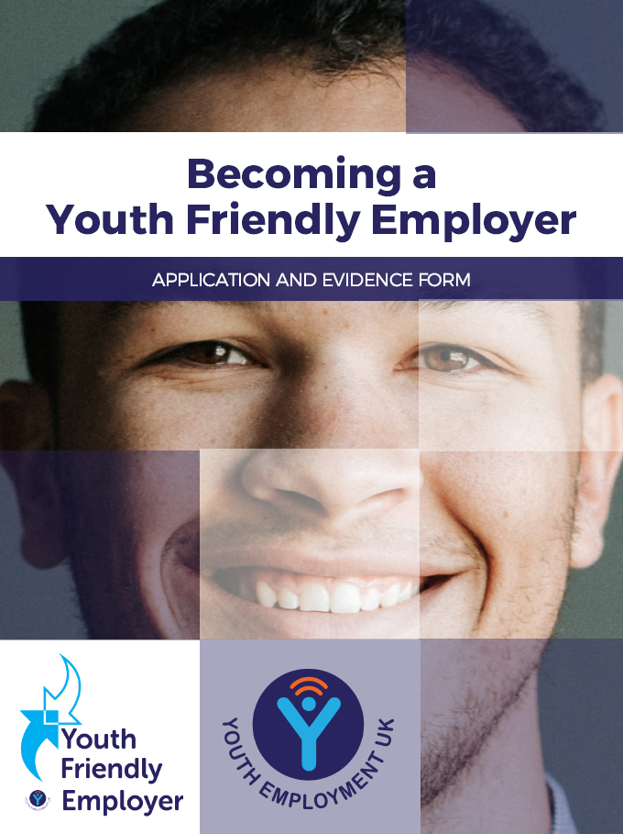

Youth Friendly Employer
APPLICATION AND EVIDENCE FORM
To be recognised as a Youth Friendly Employer your organisation must sign up to the Youth Friendly Employer Charter and complete this application form, which includes membership to the Youth Friendly Employer Community.
Company name

Company address
Postcode

No. employees

Contact name

Contact email

I confirm that the organisation listed above is committed to the Youth Friendly Employer Charter ☐
In order to be recognised as a Youth Friendly Employer you also need to be offering at least one of these three experiences to young people each year. Please tick at least one:
 |  |  | Approximately how many young people do you support through this activity?
Explore | Your organisation supports young people through early career activities in schools, colleges, youth clubs or other settings such as career fairs, CV workshops, talks etc. | ☐
Experience | Your organisation supports young people by offering quality workplace experiences | ☐
Employment | Your organisation creates quality opportunities for young people | ☐

Youth Friendly Employer Charter

Young people benefit from good quality support from employers. It helps them to understand the world of work and
potential careers. They can develop key skills and build important personal networks.
Organisations working with young people are invited to sign up to the Youth Friendly Employer Charter to demonstrate their commitment to providing quality opportunities for all young people.
------------------------------------------------------------------------------------------------------------------------------------------------------

………………………………….. [insert company name] is committed to being a Youth Friendly Employer. As part of our commitment we agree to provide young people with one or more of the following types of opportunity:

EXPLORE
Early careers support so young people can learn about the workplace

EXPERIENCE
Initiatives enabling young people to experience the workplace

EMPLOYMENT
All forms of employment so young people have the opportunity for roles in the workplace

As a Youth Friendly Employer, we will ensure that the opportunities we provide for young people meet the following principles of good youth employment practice:
Creating Opportunity – Commitment to providing diverse opportunities for young people to gain the skills and experiences they need for work and life.
Recognising Talent – Commitment to recruiting young people based on their ability, talent and potential. Understanding they are still developing and may have had limited experiences or educational attainment.
Fair Employment – Commitment to removing barriers for young people to enter the workplace. Offering fair opportunities and rewards based on the role you are recruiting for and in accordance with the highest industry standards.
Developing People - Commitment to training and supporting the development of young people, so they are motivated to take ownership and responsibility for their careers, and they are equipped to progress.
Youth Voice – Commitment to listening to young people and to providing opportunities for their voice to be heard within a community or organisation.

Signed on behalf of the organisation …………………………………………………… Date …………………………………

Signed on behalf of Youth Employment UK ………………………………………… Date …………………………………

Booking Form
Please choose the package(s) you would like to apply for below. | Total number of employees in your organisation
 | 1-20 | 21-50 | 51-100 | 101-999 | 1000-4999 | 5000+
Youth Friendly Employer with Youth Friendly Employer Community Membership  Benefits:  - Charter certificate (PDF)  - Use of Youth Friendly Employer logo  - Company details included in our Careers Hub Youth Friendly Employer database  - Access to our online Youth Friendly Employer Community featuring supporting resources, templates, events, networking and webinars | £150  ☐ | £200  ☐ | £350  ☐ | £500  ☐ | £750  ☐ | £1000  ☐
Careers Hub Profile *  Benefits:  - Technical development and build  - Upload of career roles, videos and case studies  - Support with recruitment campaigns  * only available to Youth Friendly Employers | £450  ☐ | £600  ☐ | £750  ☐ | £1000  ☐ | £1500  ☐ | £2000  ☐
Youth Friendly Employer Gold Standard Assessment *  Benefits:  - Consultancy support to prepare for your assessment  - Award Assessment  - Case Study and promotion of your assessment outcome  - Automatic entry into our annual awards  * only available to Youth Friendly Employers | £300  ☐ | £300  ☐ | £300  ☐ | £500  ☐ | £1000  ☐ | £1500  ☐
Bespoke Services  We can tailor a range of services to suit your needs. These include but are not limited to:  - Consultancy and strategic support  - Youth Consultation and workshops  - Support with school outreach  - Education services design including lesson plans  - Policy Engagement through our APPG and wider government work | ☐  Please tick this box and we will be in touch to discuss how we can support you

Please see our full terms and conditions in this document.

ACCOUNTS DEPARTMENT DETAILS
Accounts contact name
Accounts Telephone Number
Accounts Email Address

Company Name (to appear on invoice)
Full Address (to appear on invoice)
PO Number (if required)
Company Registration Number
Company VAT Number
Do you need Youth Employment UK to complete a New Supplier Form?
If Yes, please send with completed registration form
Any other information that will help us to ensure that the process runs smoothly

Please sign and return the Application Form by email to info@youthemployment.org.uk, or by post to Youth Employment UK, 17 Station Road, Kettering, Northants, NN15 7HH.

By signing this form, you are confirming that you are authorised on behalf of your company to apply to become a Youth Friendly Employer. You are also confirming acceptance of our Terms and Conditions.

Print name
Signature
Date

Terms & Conditions
These terms and conditions form the basis of the contract your organisation will have with Youth Employment UK. Youth Employment UK will deliver a service to you as a Youth Friendly Employer. On signing this agreement, you confirm you are agreeing to these terms and conditions.

Youth Employment UK is a not-for-profit Community Interest Company, limited by guarantee. Our registered office is 20 Breck Close, Great Oakley. Corby. NN18 8JR. Our trading address is 17 Station Road, Kettering. Northants. NN16 7HH

As a Youth Friendly Employer, you are entitled to the following benefits:
- Annual membership to the Youth Friendly Employment Online Community which provides:
  - Best practice, case studies and online support
  - Youth employment resources and templates
  - Expert webinars covering a range of youth employment topics
  - Policy insights and attendance at APPG Meetings
  - Opportunities to connect to other organisations invested in youth employment
  - A listing on the Youth Friendly Employer Database featured on our Careers Hub

As an Employer Profile customer, you are entitled to the following benefits:
- Annual membership to the Youth Friendly Employment Online Community
- A profile on the Careers Hub, which provides you with the opportunity to upload Career Roles, Videos and Case Studies
- Support with recruitment campaigns via our social media channels (a maximum of three campaigns a year)
- Opportunities to be featured in our newsletters and on the Young Professional Dashboard

As a Gold Standard Youth Friendly Employer, you are entitled to the following benefits:
- Annual membership to the Youth Friendly Employment Online Community
- Consultancy support to prepare for your application (max of 2 hours)
- Award Assessment
- Case Study and Promotion of your assessment outcome
- Automatic entry into our annual awards

We reserve the right to change the benefits that apply to Youth Employment UK at any time and without prior notice.

Working with Youth Employment UK your commitment to us

- To be an Ambassador for Youth Friendly Employers, to support Youth Friendly Employer through communication and promotion within your network.
- To support Youth Employment UK with surveys and data collection that is required to support youth employment analysis

All of our Youth Friendly Employers are expected to follow our code of conduct:

- To work to the five principles of youth friendly employment - Youth Voice, Creating Opportunity, Recognising Talent, Fair Employment and Developing People. Failure to comply may result in the removal of your award and associated services.
Contract
When you submit the registration form for the Youth Friendly Employer you are accepting these terms and conditions on behalf of your organisation. Youth Friendly Employer benefits will commence on the date on the booking form and runs for 12 months.

Cooling off period
We offer a seven working days’ cooling off period for new members, effective from the day your application is received. This will allow you to cancel your application without any penalty.

Renewals
Renewals are generated automatically, should you wish to cancel as a Youth Friendly Employer you must provide notice in writing one month before the renewal date. Upon renewal your organisation will be subject to these same terms and conditions.
No refunds will be provided if the cancellation notice is not met.

Rights to cancel
We reserve the right not to fulfil, or to cancel your application if we are unable to obtain payment from your organisation.
We reserve the right to cancel or withdraw Youth Friendly Employer status at anytime.

Price Information
Fees displayed on the Organisation section of the website will prevail at all times.
We reserve the right to increase the price of the Youth Friendly Employer on an annual basis. You will be informed of any fee increase in your renewal letter.

Payment and Payment Terms
Payment can be made by BACS or Cheque and must be made within 14 days of receipt.
Bank Details: Barclays Bank. Sort Code: 20-45-77 Account Number:50916668
Cheques can be made payable to: Youth Employment UK
We have a statutory right under the Late Payment of Commercial Debts Regulations 2013 to add interest and late payment compensation to any overdue payments.

Data protection and use of personal data
The information you provide will be used to process your subscription, this will involve creating a personalised log in on our website (www.youthemployment.org.uk), adding you to our members mailing list and to our internal CRM system. This information will only be used to ensure that you can access our services as required and that you are being kept up to date. You reserve the right to be removed from our mailing list and website at any time.
We may ask that we use your company information or logo for promotional material from time to time.
We do not pass data to any third parties. You can read our full privacy statement here
If you wish to obtain a copy of your personal data held by us, then please write to us at our head office. We will store data for up to two years after your contract ends with us.
If you believe that any of the information we hold concerning you is incorrect or out of date, please provide us with accurate information by emailing info@youthemployment.org.uk You may update your company information through your online profile.

Variation
We may change these terms and conditions at any time upon giving you 14 days prior written notice. The most recent edition of these terms and conditions will be binding upon you.
Community Members may exit the contract if they do not accept any proposed variation.

Governing law and jurisdiction
These terms and conditions are governed by English law. You hereby irrevocably submit to the exclusive jurisdiction of the English courts notwithstanding the jurisdiction where you are based.

Entire Agreement
These terms and conditions override any contrary terms or conditions published by us in relation to any other subscriptions between you and us.

Queries and Complaints
If you have any queries, comments or complaints please contact us on info@youthemployment.org.uk or write to us at 17 Station Road, Kettering, Northants, NN15 7HH

